MINI PROJECT
FATHIMA MINHA .P
1. Data Pre-processing using Excel
○ Perform cleaning and transformation tasks on raw data, such as:
■ Removing duplicates
■ Handling missing values
■ Standardizing formats
■ Creating calculated fields (if required)
■ Filtering and sorting
■ Creating Pivot Tables (if required)
DATA SET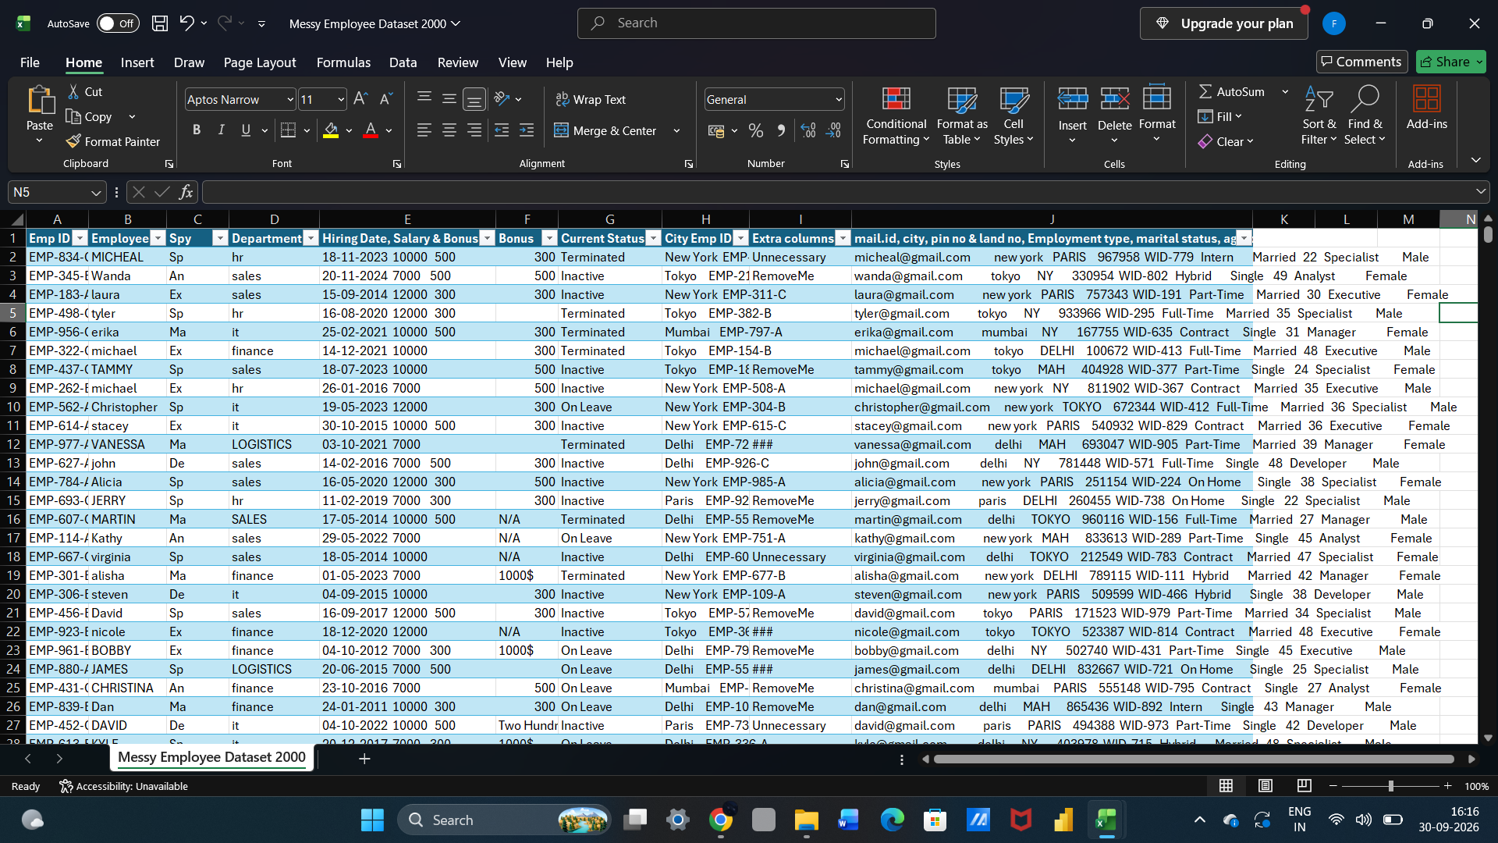
Cleaned data set using text to column
Go to the data tab select the text to column and separate with comma.
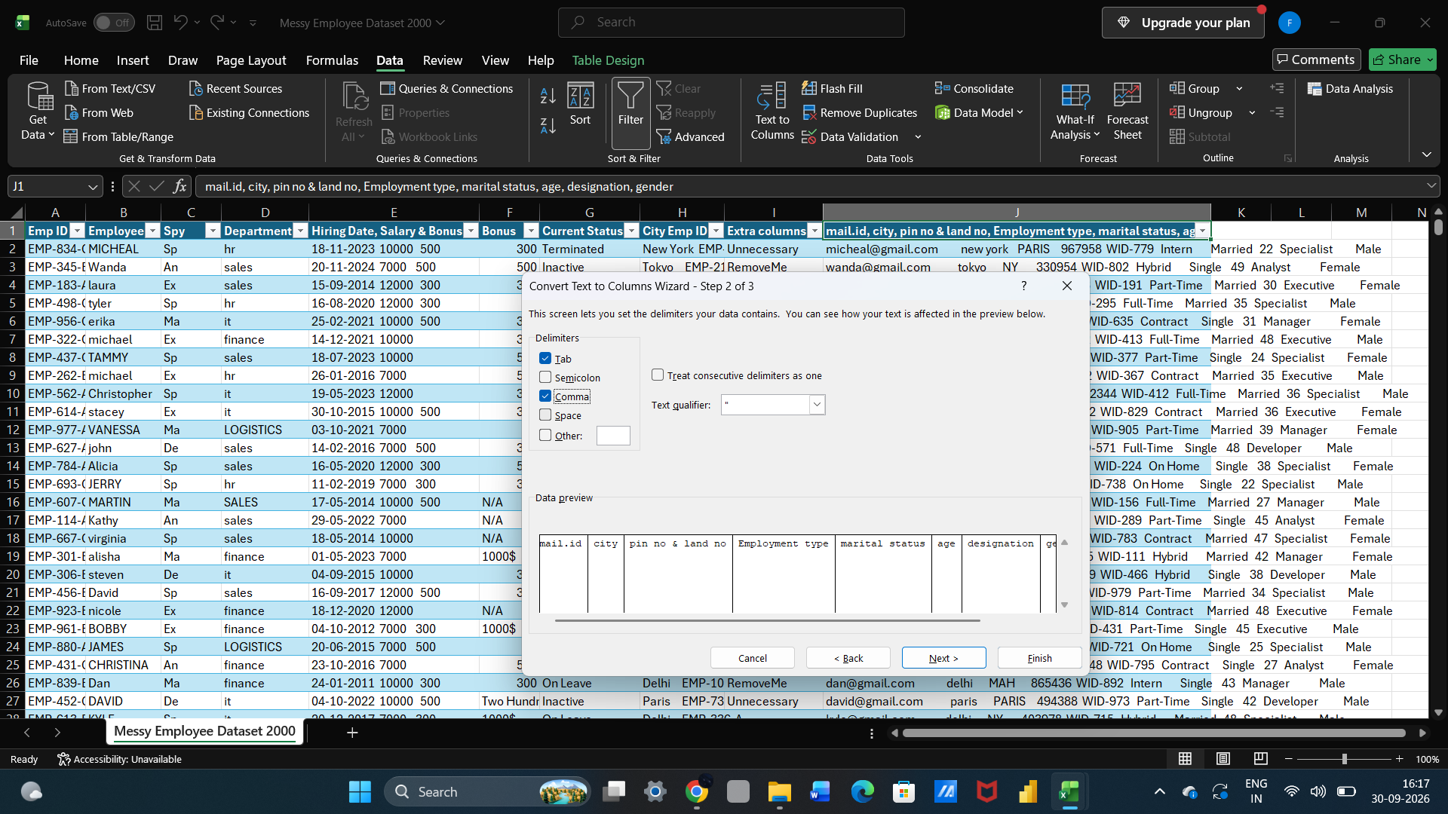
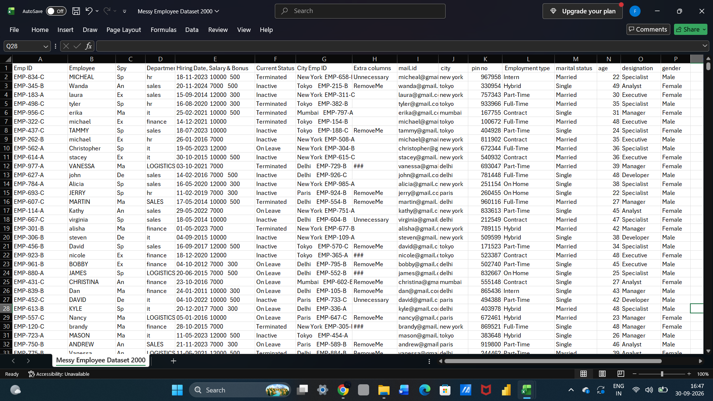

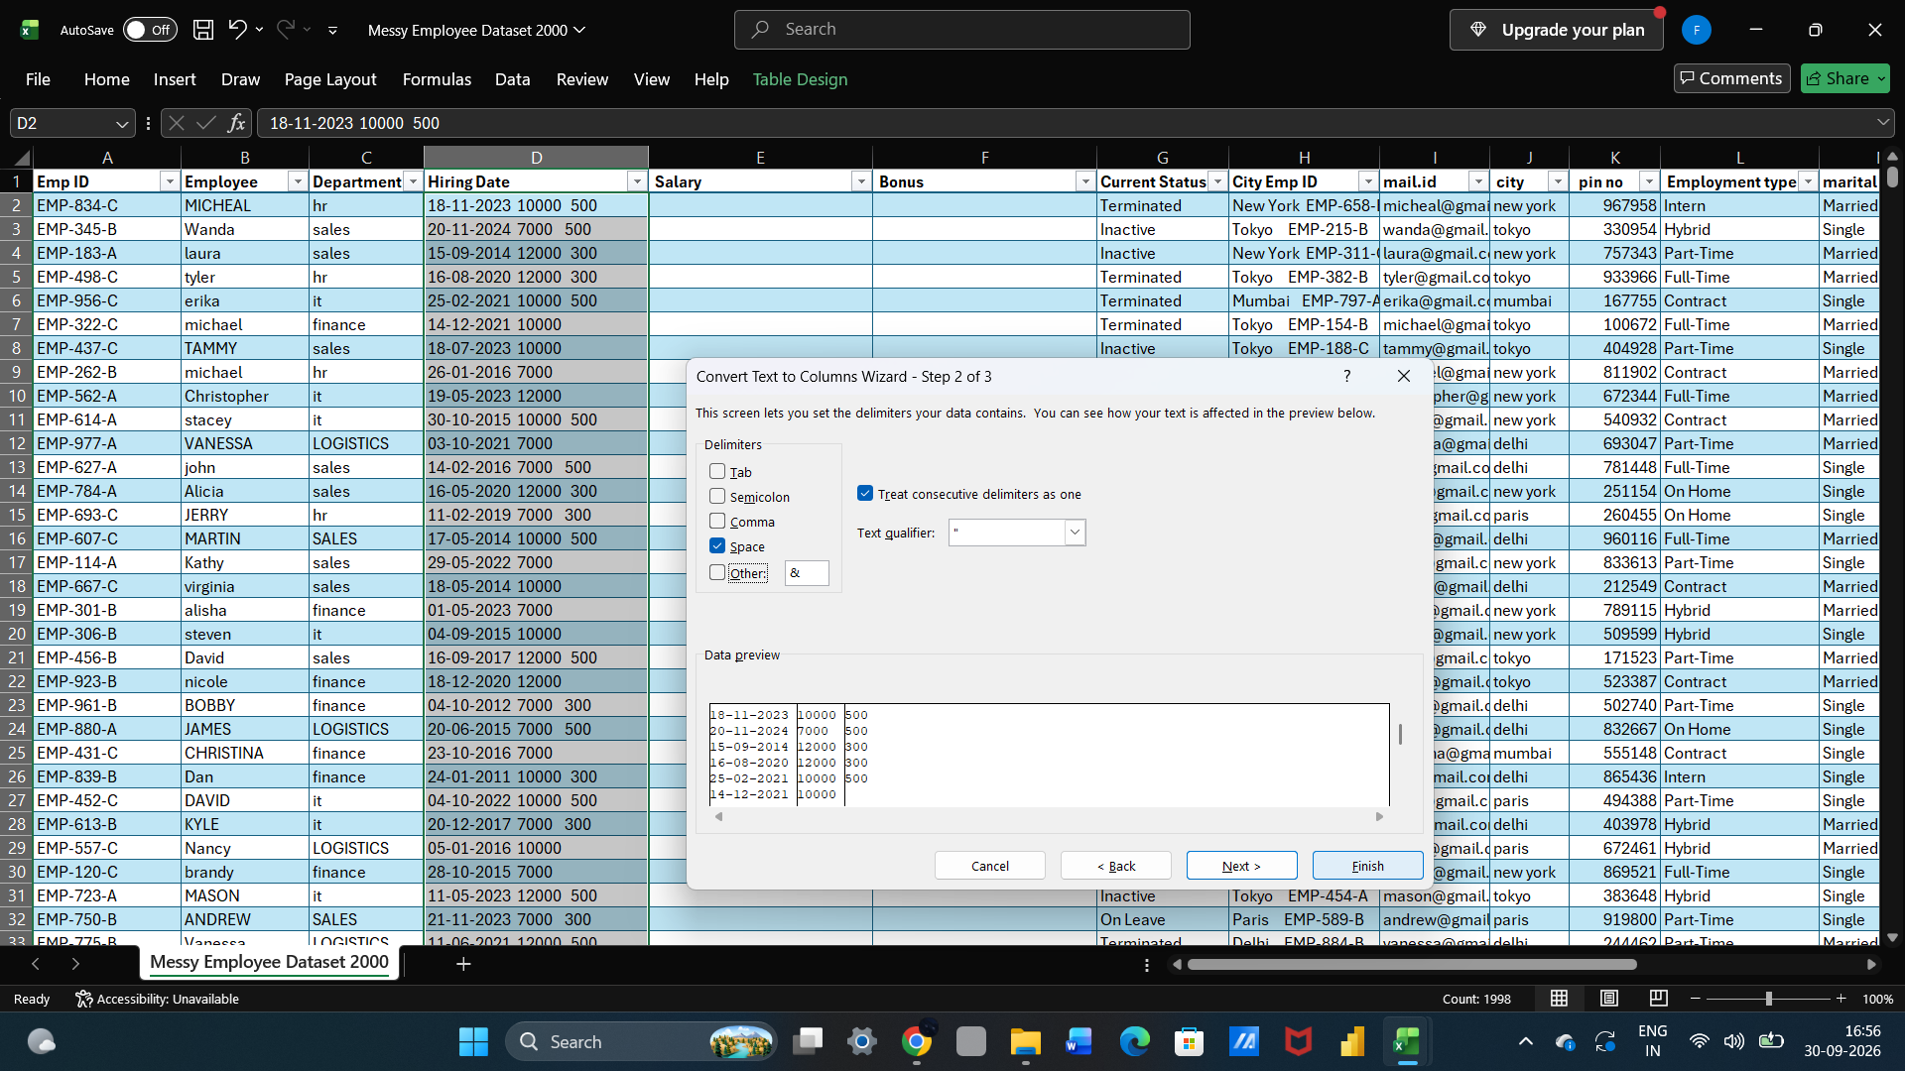
This separation using space used.
Remove unwanted columns
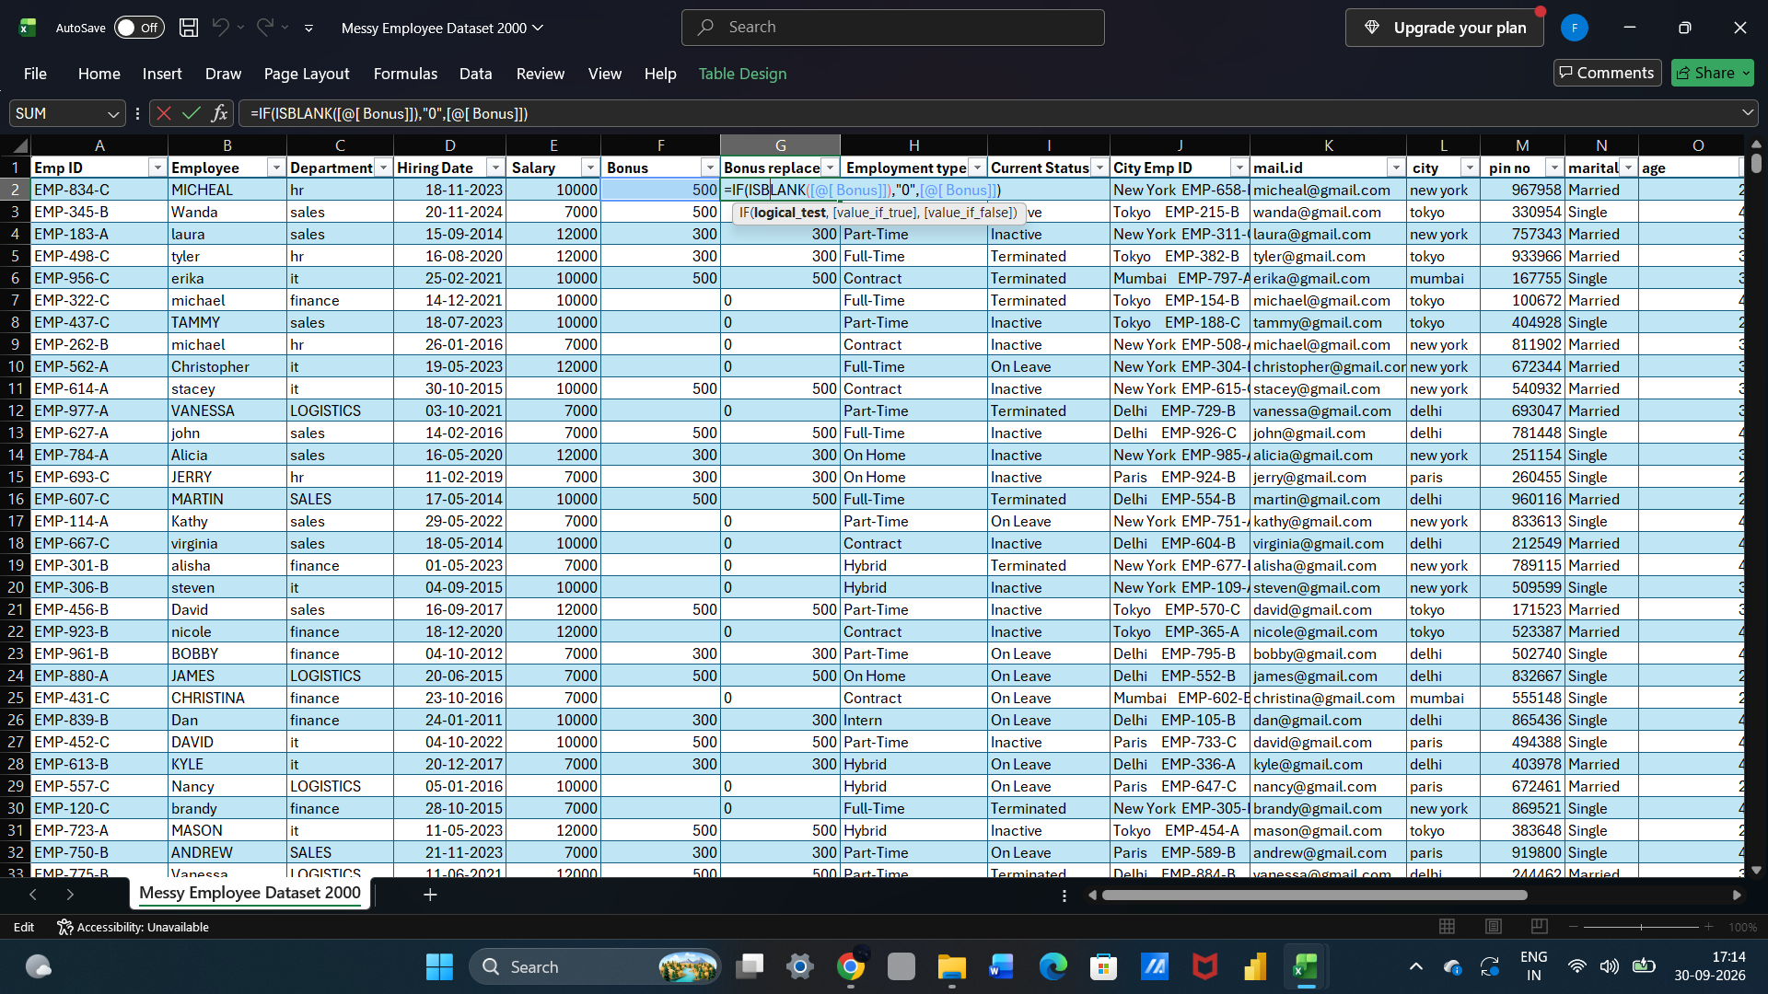

Removing duplicate
Go to the data tab select remove duplicate.
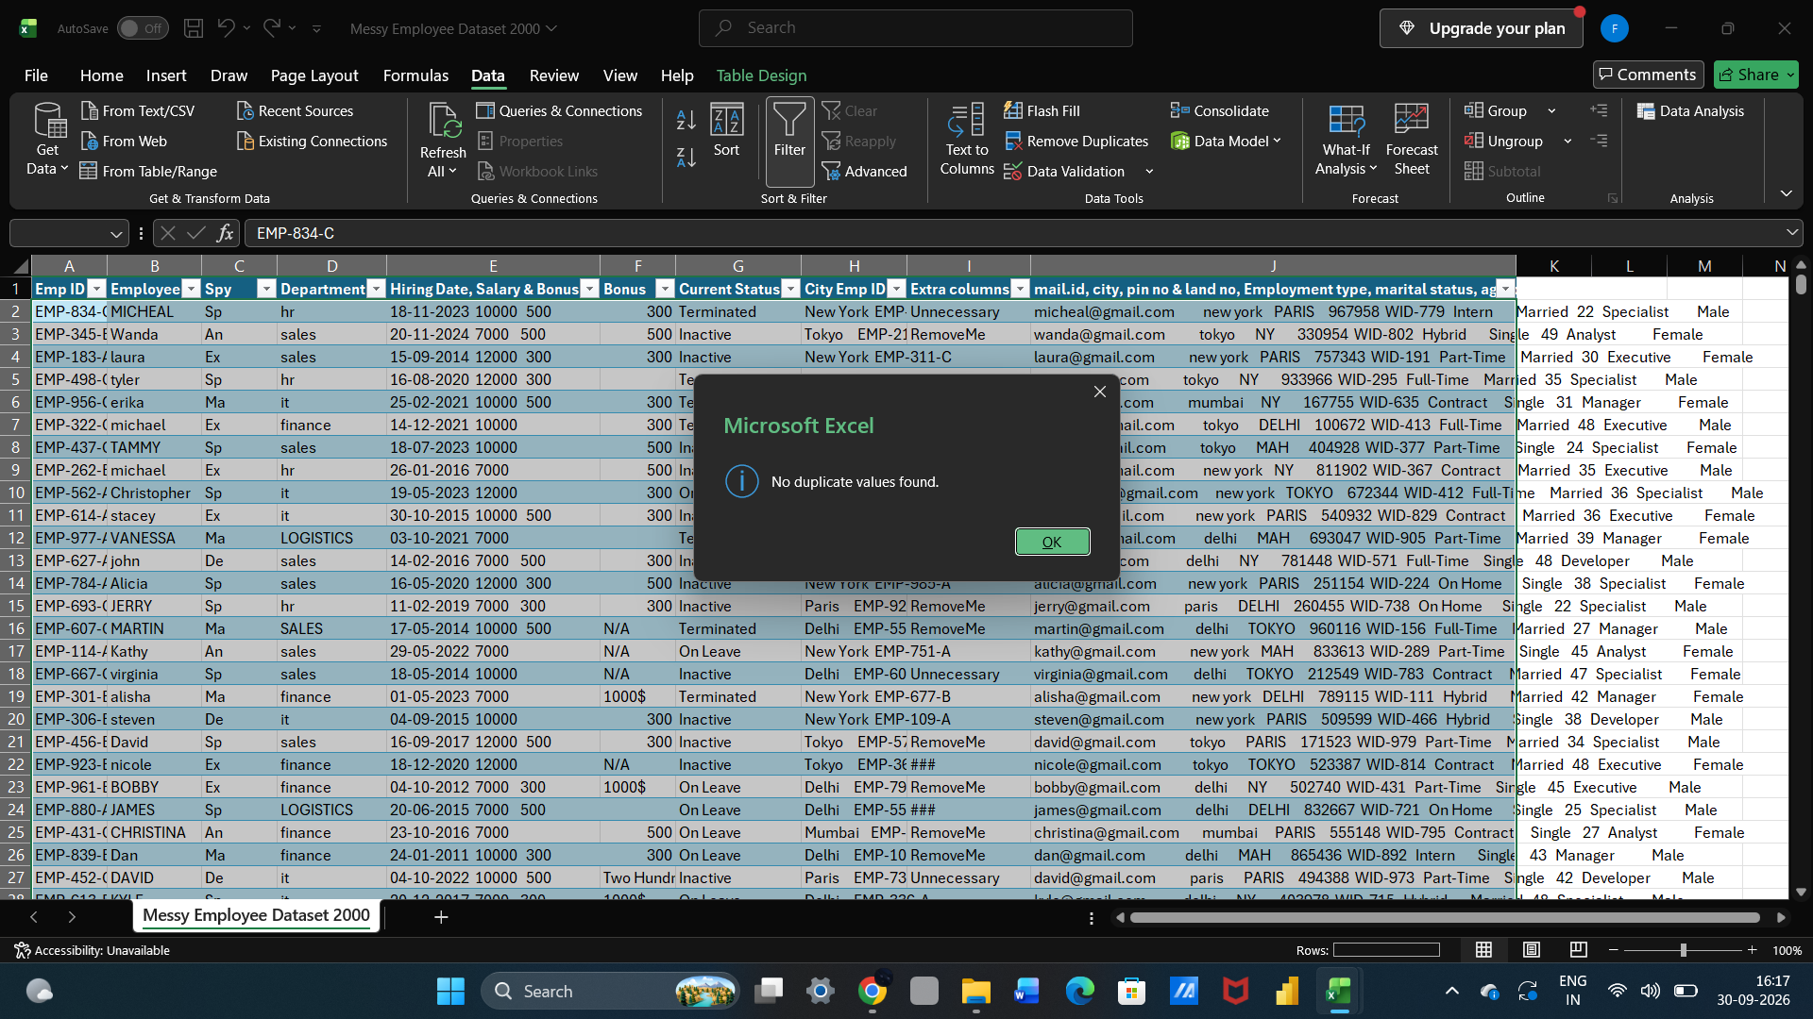
The missing bonus replaced using IF function
=IF(ISBLANK([@[ Bonus]]),"0",[@[ Bonus]])
■ Standardizing formats
Standizing using find and replacement function.
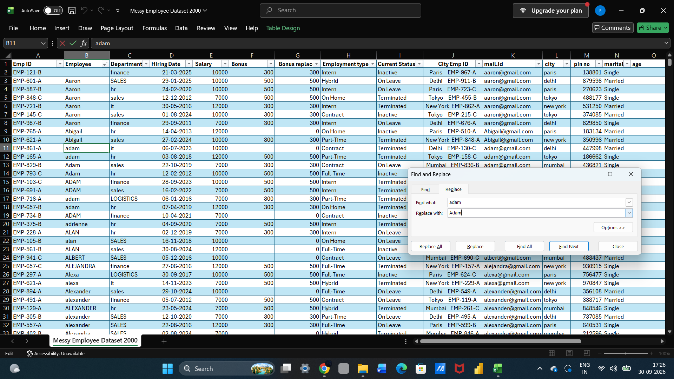
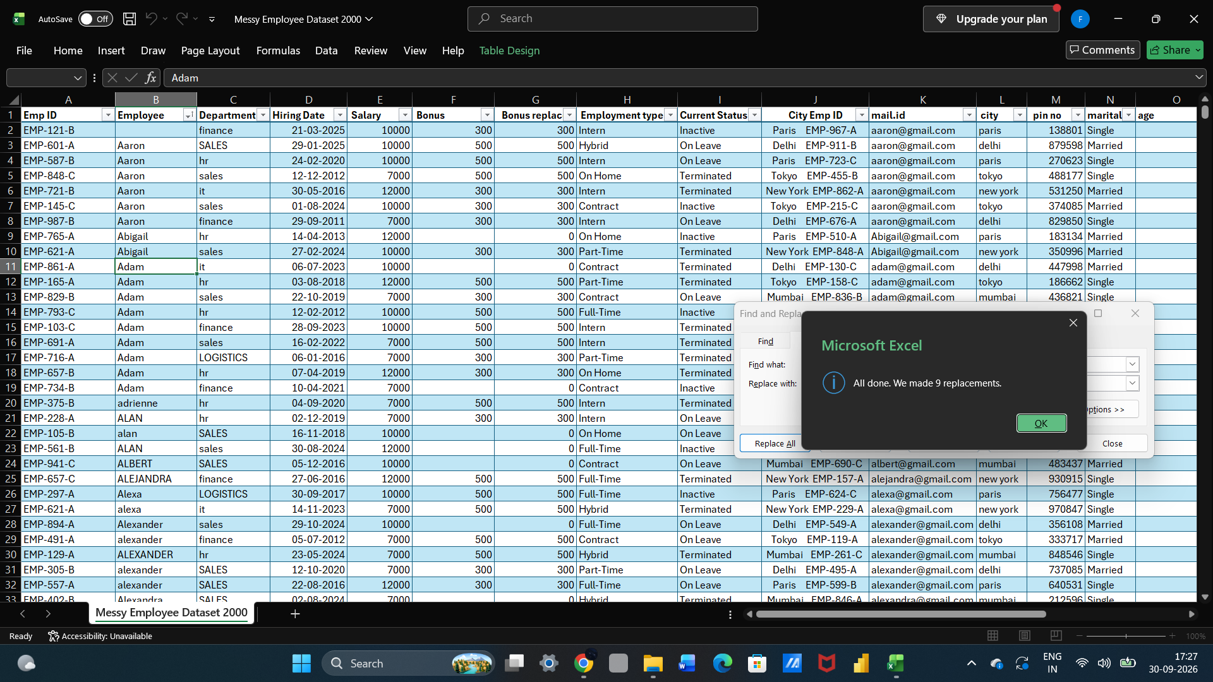
Remove row
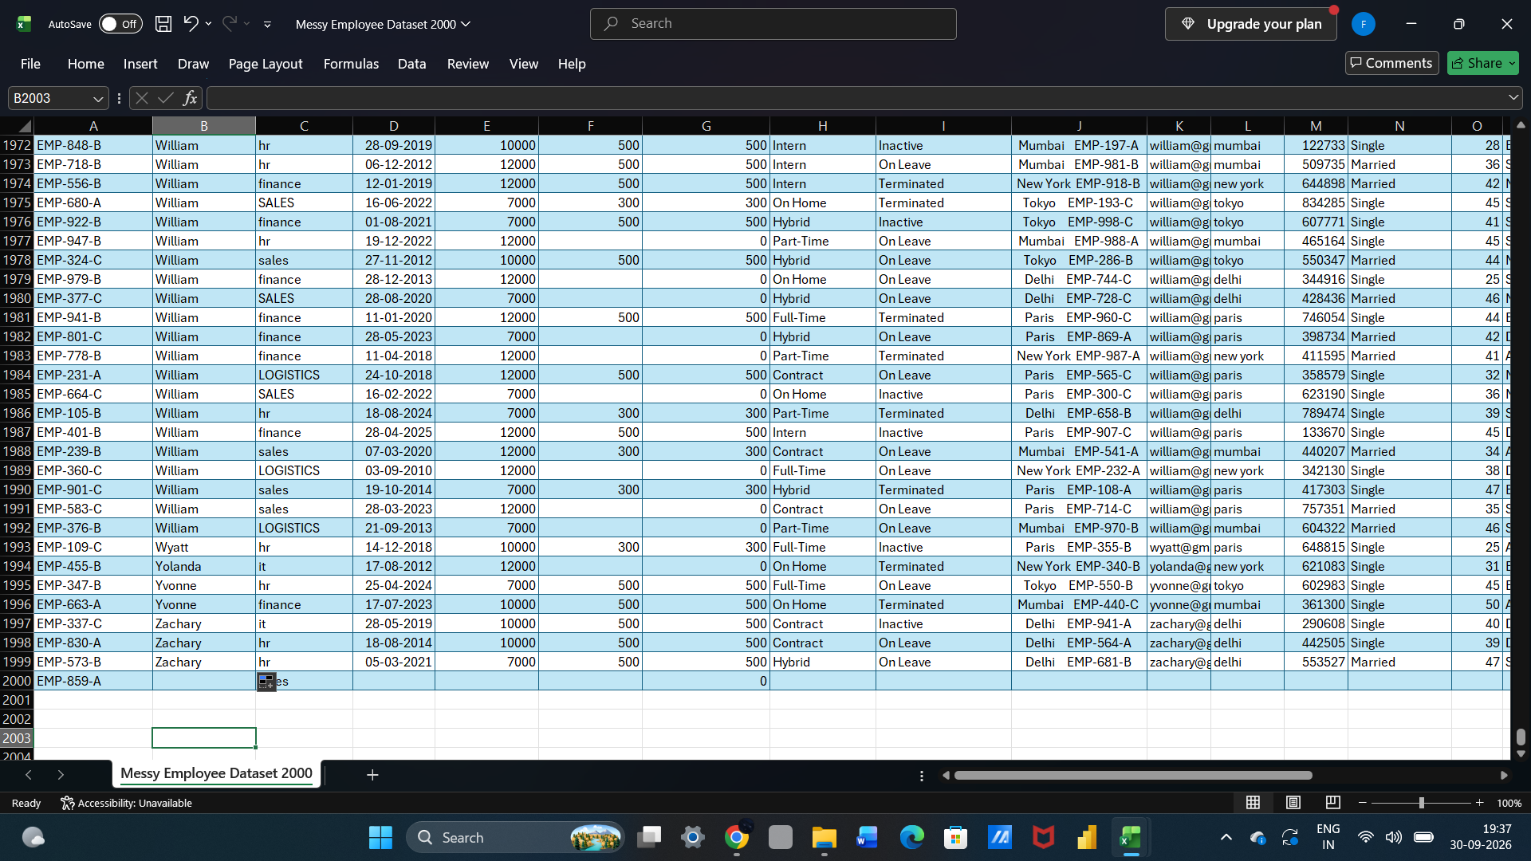
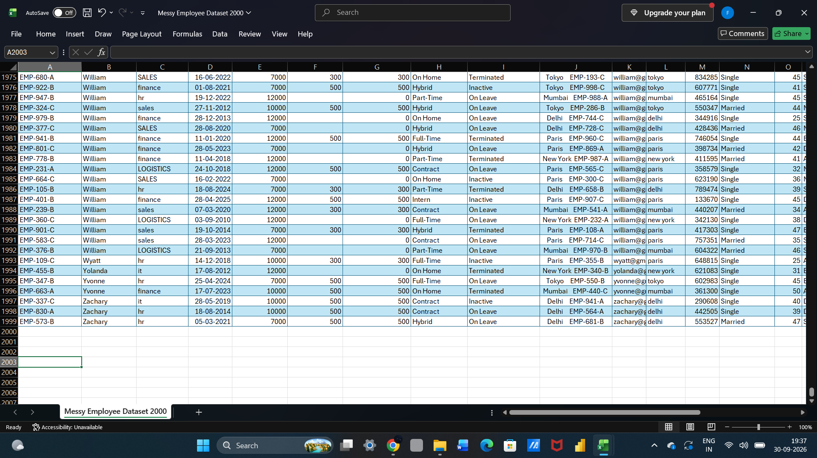
Create the pivot tables
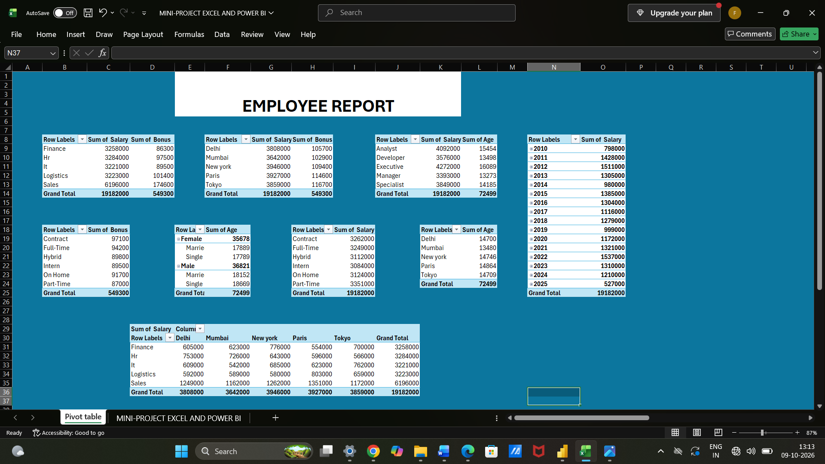
2. Data Visualization using Power BI
○ Build a report/dashboard with:
■ Multiple visualizations that communicate insights clearly
■ Appropriate use of charts (bar, line, pie, slicers, cards, etc.)
■ Clear and interactive layout (using filters, slicers, drill-downs, etc.) ■ Proper titles, labels, and legends
Multiple visualizations that communicate insights clearly
Funnel visualization
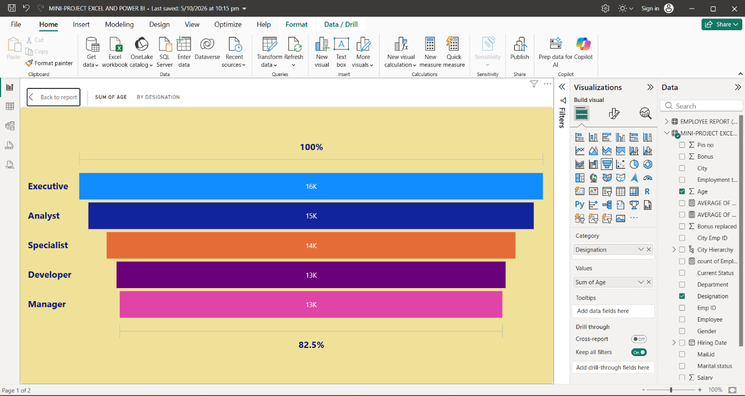
Tree map
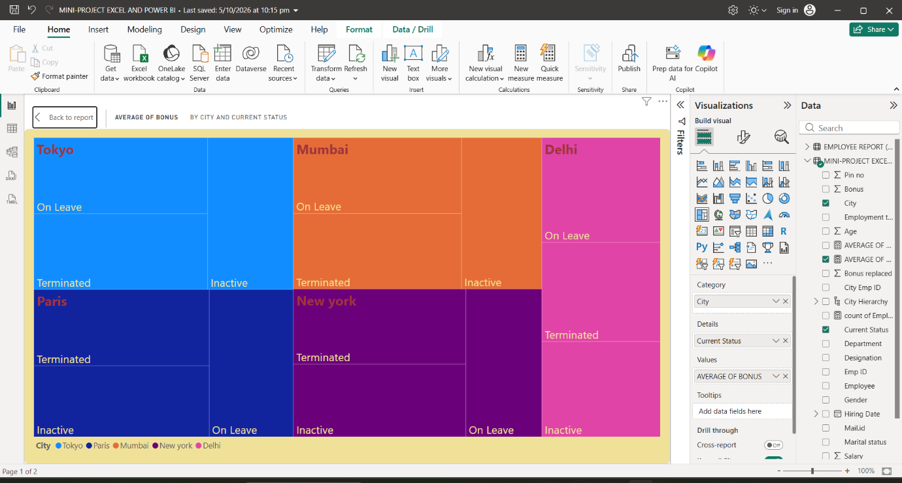
Gauge
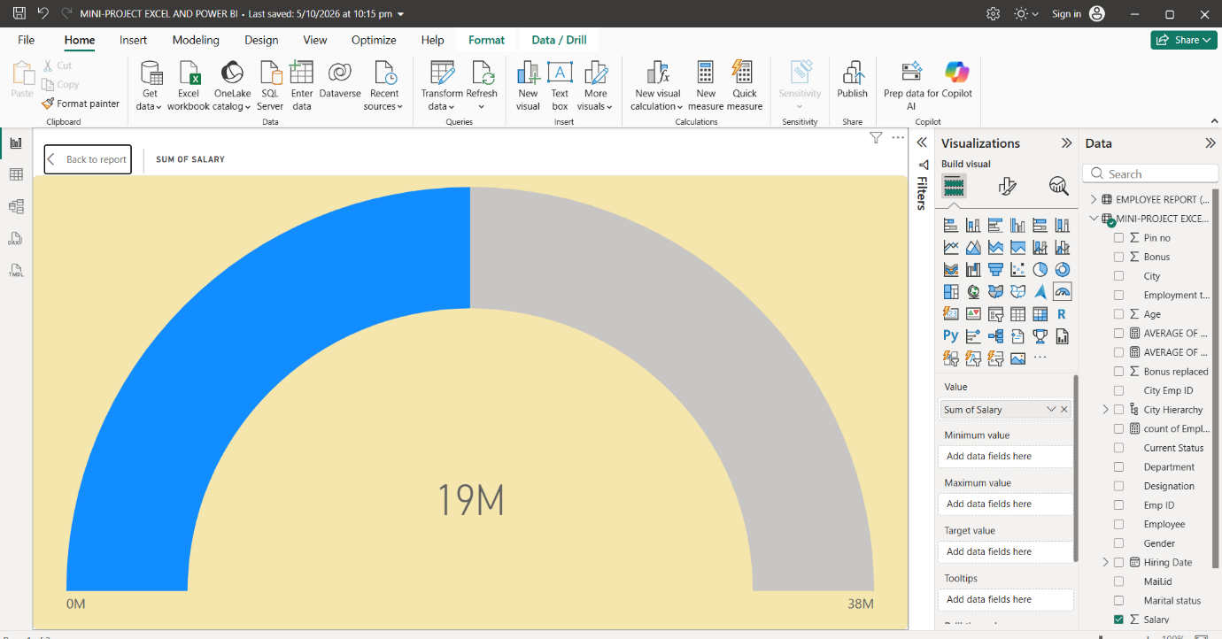
Matrix
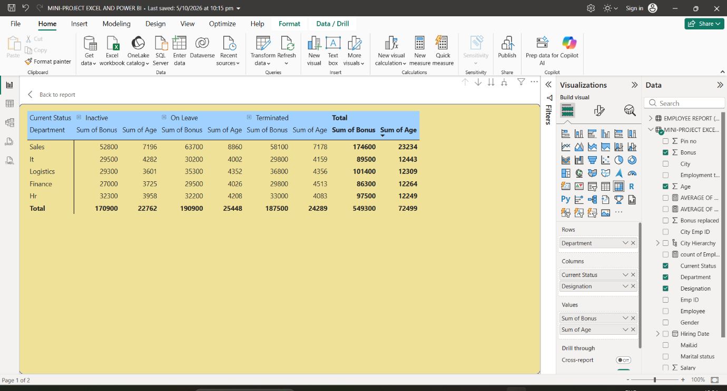
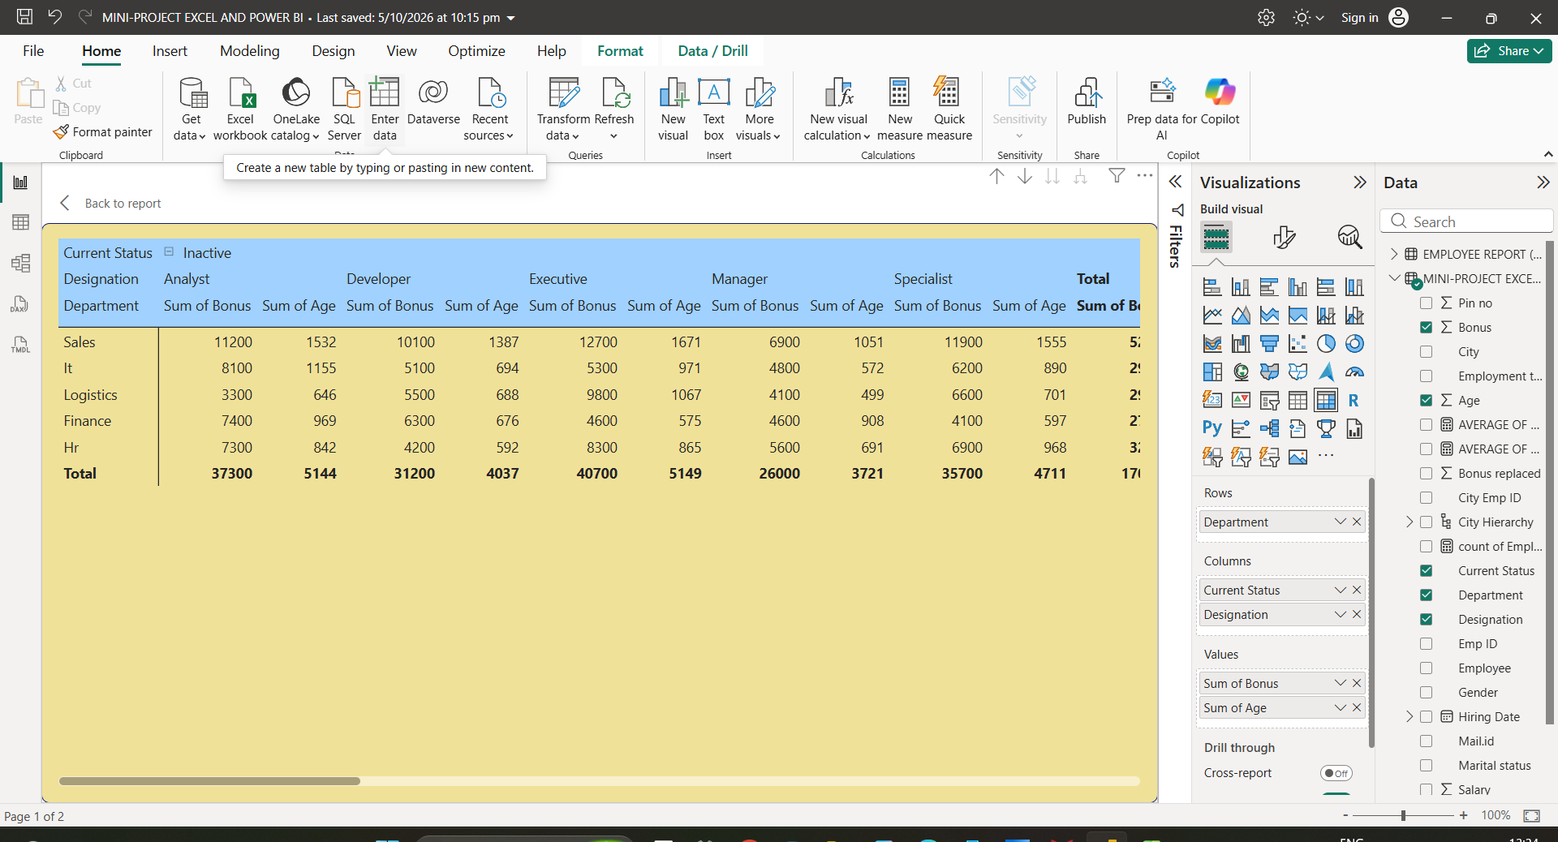
■ Appropriate use of charts (bar, line, pie, slicers, cards, etc.)
Bar chart
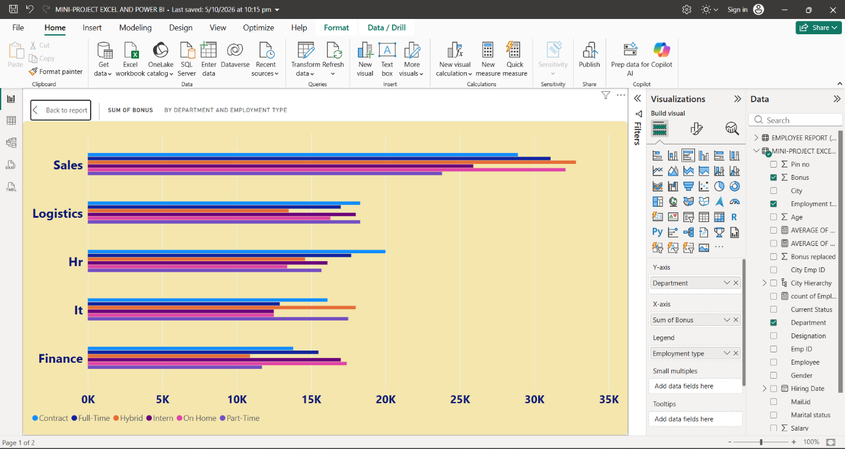
Line chart
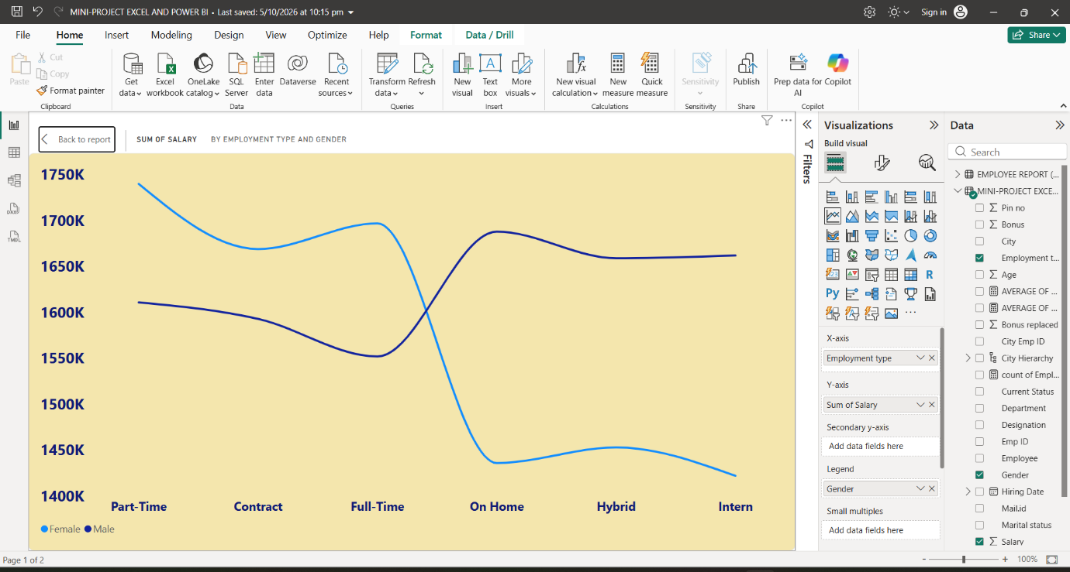
Pie chart
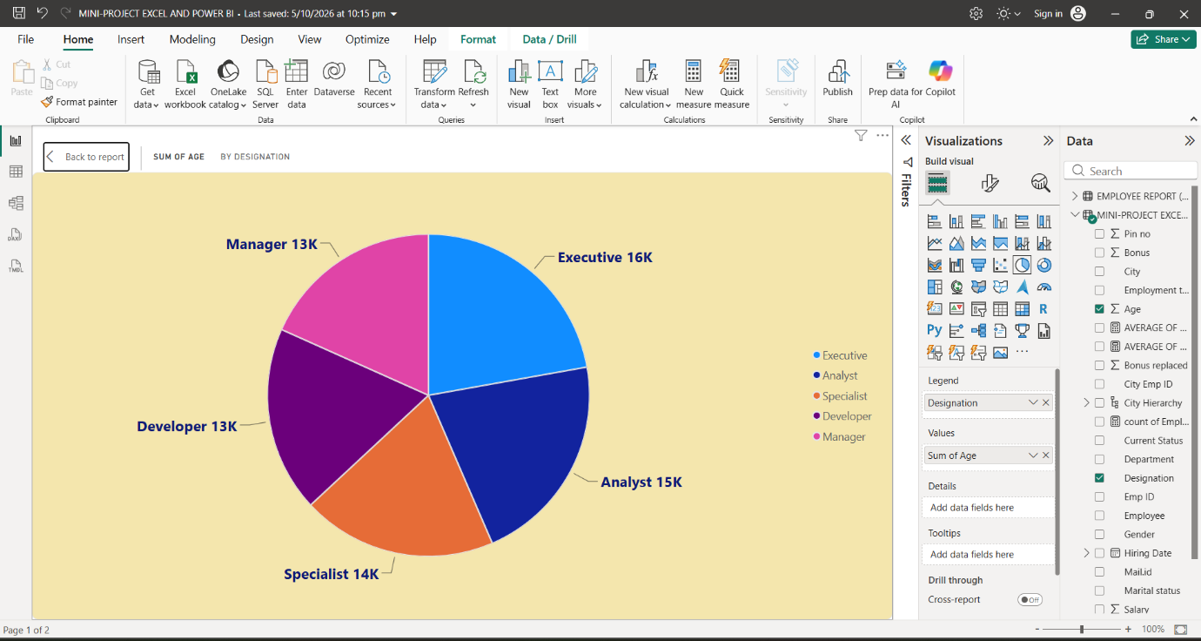
Slicers
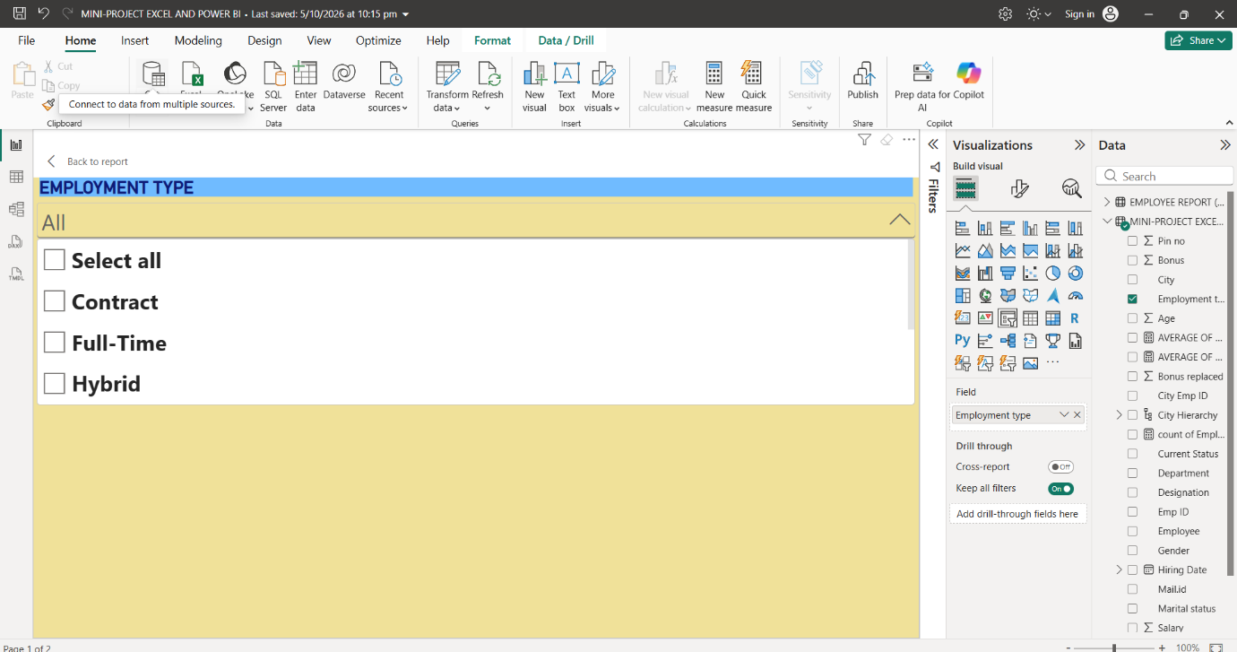
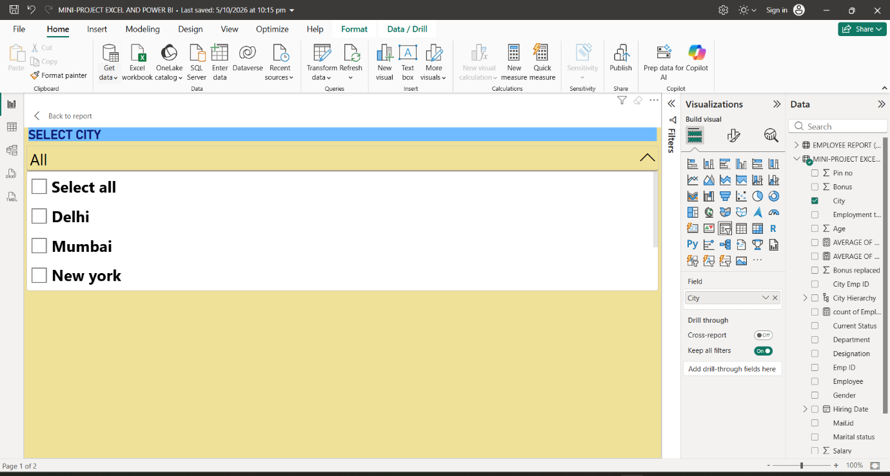

Dashboard
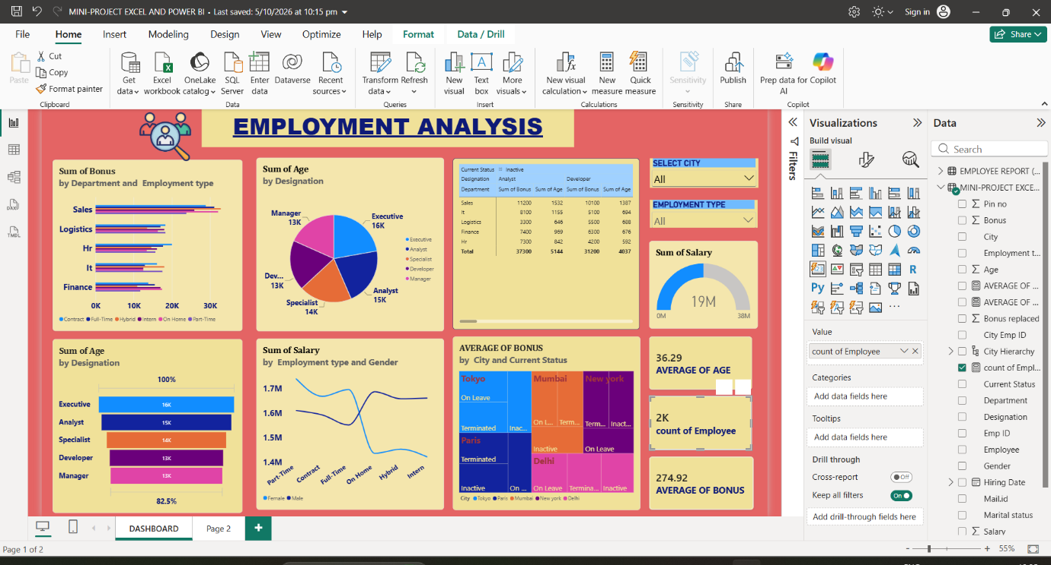
Drill-downs

